

**VILNIUS UNIVERSITY  
SIAULIAI ACADEMY**

PROGRAMŲ SISTEMOS BACHELOR STUDY PROGRAMME

Software engineering

**ANNA KUTOVA**

**Computer Networks**

**Laboratory work No.3**

**TCP**

Šiauliai, 2025

# **Laboratory Work Report**

# Table of contents

1. Capturing a bulk TCP transfer from your computer to a remote server 2

2. A first look at the captured trace 2

3. TCP Basics 3

4. TCP congestion control in action 5

## 1. Capturing a bulk TCP transfer from your computer to a remote server

## 2. A first look at the captured trace

1. *What is the IP address and TCP port number used by the client computer (source) that is transferring the file to gaia.cs.umass.edu?*

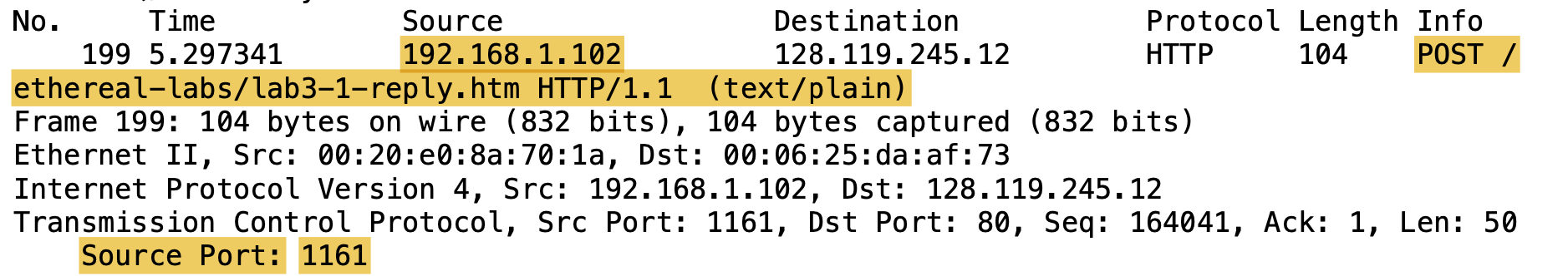

**Answer:**

1. IP address: **192.168.1.102**
2. TCP port number: **1161**
3. *What is the IP address of gaia.cs.umass.edu? On what port number is it sending and receiving TCP segments for this connection?*

**

**Answer:**

1. IP address (gaia.cs.umass.edu): **128.119.245.12**
2. TCP port number: **80**
3. *What is the IP address and TCP port number used by your client computer (source) to transfer the file to gaia.cs.umass.edu?*

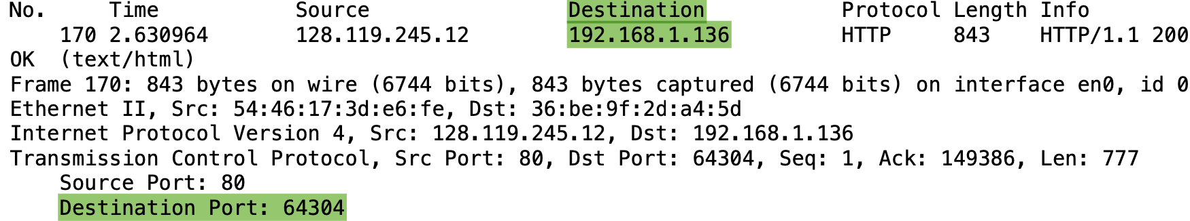

**Answer:**

1. The IP address used by my client computer (source) is: **192.168.1.136**
2. The TCP port number used by my client computer (source) is: **64304**

## 

## 

## 3. TCP Basics

1. *What is the sequence number of the TCP SYN segment that is used to initiate the TCP connection between the client computer and gaia.cs.umass.edu?*

*What is it in the segment that identifies the segment as a SYN segment?*

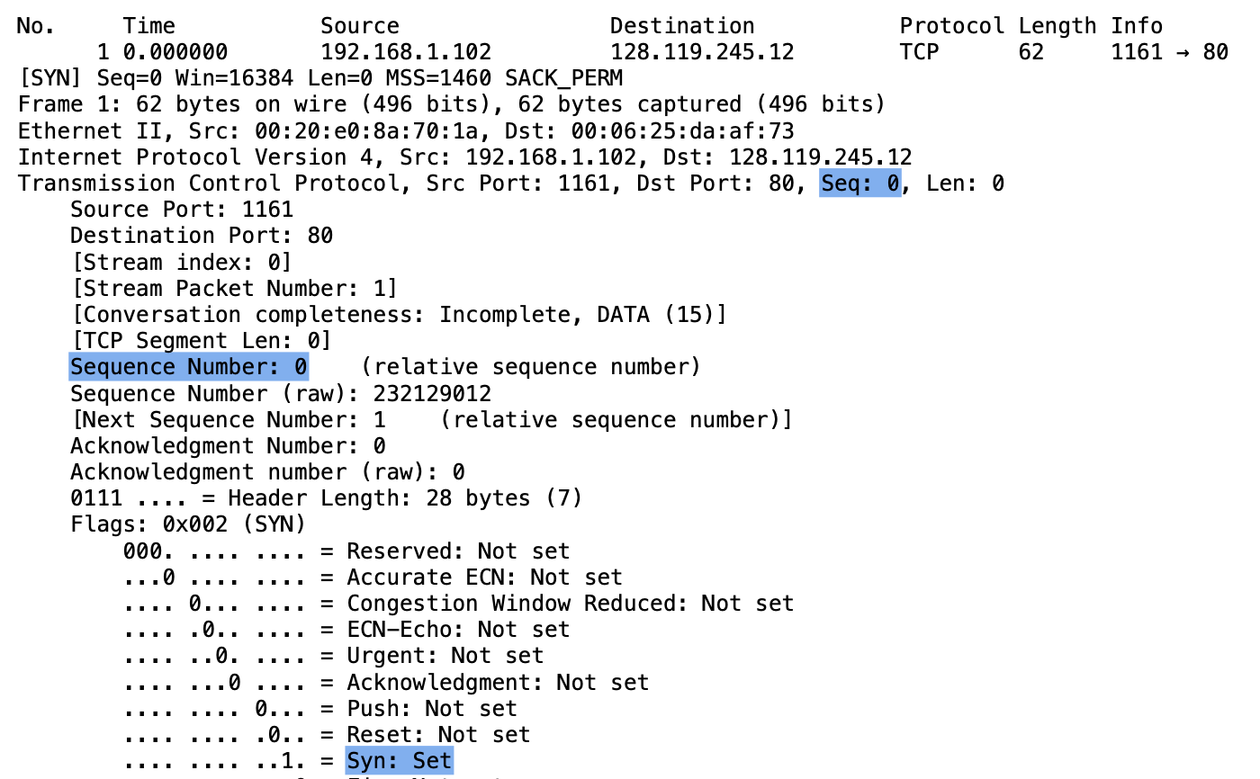

**Answer:**

1. The sequence number of the TCP SYN segment that is used to initiate the TCP connection between the client computer and [gaia.cs.umass.edu](http://gaia.cs.umass.edu) is **0**
2. **Syn Flag is Set**, which identifies that the segment is a SYN segment
3. *What is the sequence number of the SYNACK segment sent by* [*gaia.cs.umass.edu*](http://gaia.cs.umass.edu) *to the client computer in reply to the SYN?*

*What is the value of the Acknowledgement field in the SYNACK segment?*

*How did* [*gaia.cs.umass.edu*](http://gaia.cs.umass.edu) *determine that value?*

*What is it in the segment that identifies the segment as a SYNACK segment?*

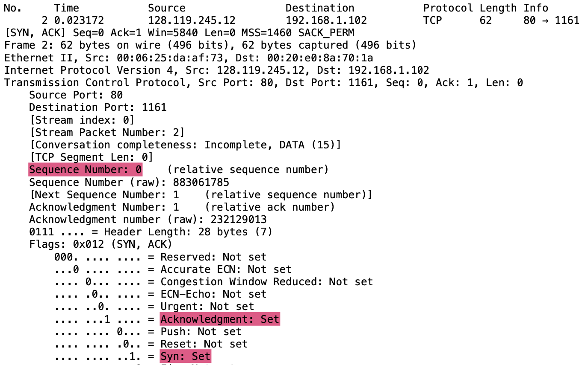

**Answer:**

1. the sequence number of the SYNACK segment sent by gaia.cs.umass.edu to the client computer in reply to the SYN is **0**
2. the value of the Acknowledgement field in the SYNACK segment is **Set (1)**
3. In the segment, both **SYN** and **ACKnowledgement** flags are Set (both are equal 1), which identifies the segment as a SYNACK
4. *What is the sequence number of the TCP segment containing the HTTP POST command? Note that in order to find the POST command, you’ll need to dig into the packet content field at the bottom of the Wireshark window, looking for a segment with a “POST” within its DATA field.*

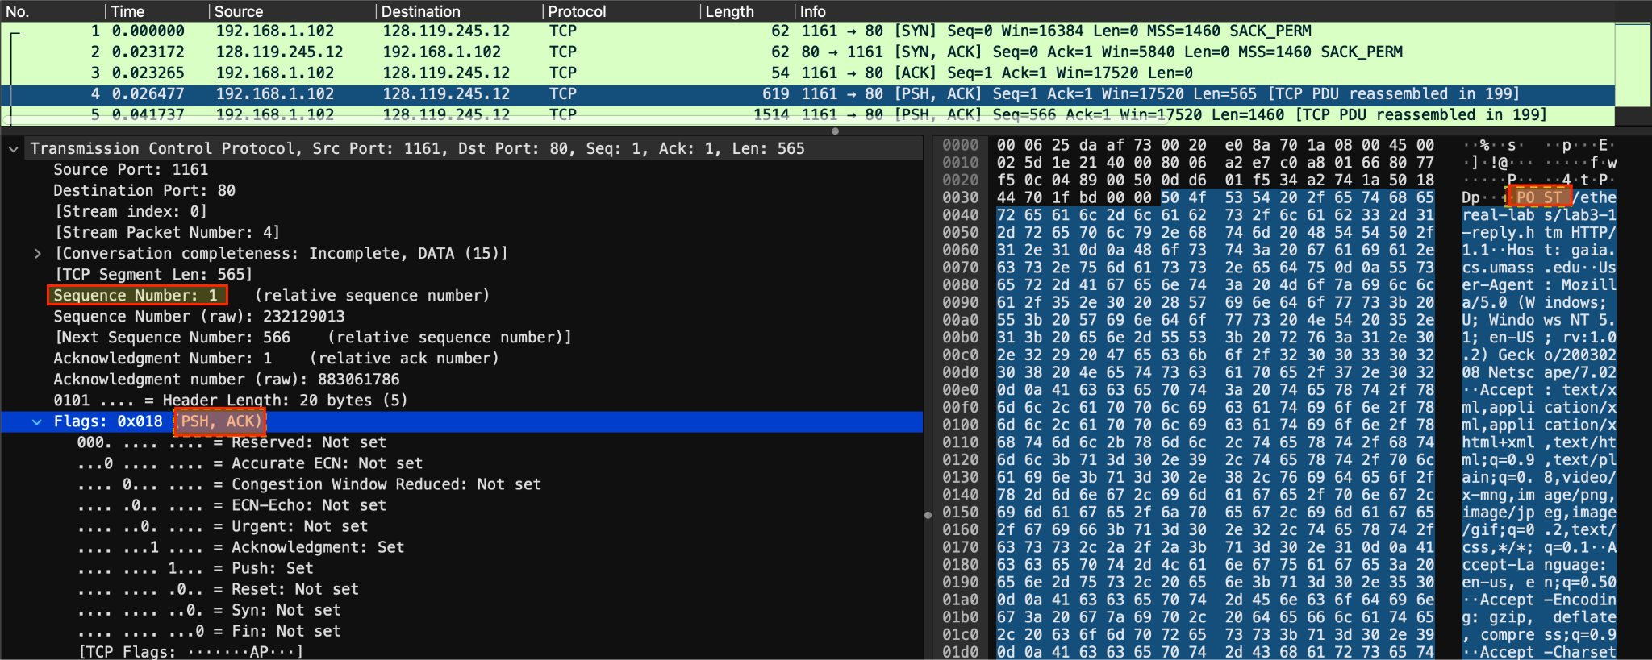

**Answer:** the sequence number of the TCP segment containing the HTTP POST command is **1**

1. *Consider the TCP segment containing the HTTP POST as the first segment in the TCP connection. What are the sequence numbers of the first six segments in the TCP connection (including the segment containing the HTTP POST)? At what time was each segment sent? When was the ACK for each segment received?*

*Given the difference between when each TCP segment was sent, and when its acknowledgement was received, what is the RTT value for each of the six segments?*

*What is the* ***EstimatedRTT*** *value (see Section 3.5.3, page 242 in text) after the receipt of each ACK?*

*Assume that the value of the* ***EstimatedRTT*** *is equal to the measured RTT for the first segment, and then is computed using the* ***EstimatedRTT*** *equation on page 242 for all subsequent segments.*

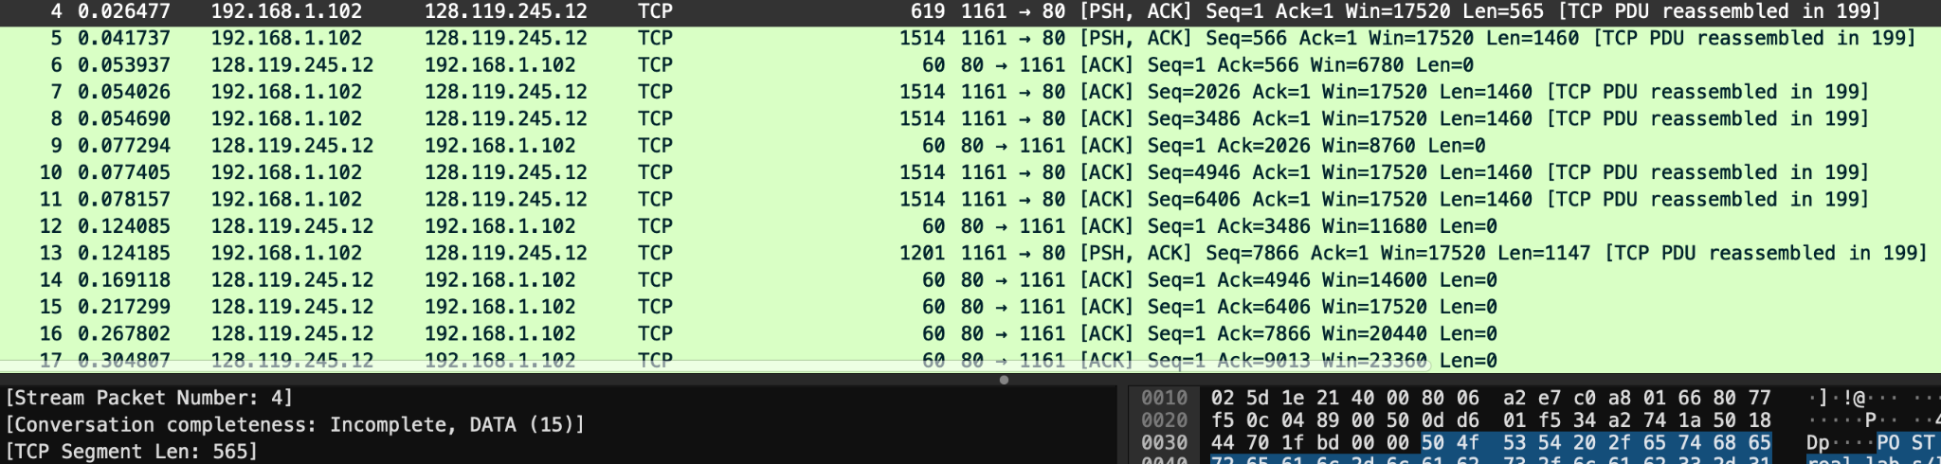

**Answer:**

According to the screenshot the first six segments are: 4, 5, 7, 8, 10,11

First ACK six segments are: 6, 9, 12, 14 - 16.

Sequence numbers:

(4) Segment 1: 1

(5) Segment 2: 566

(7) Segment 3: 2026

(8) Segment 4: 3486

(10) Segment 5: 4946

(11) Segment 6: 6406

| **Segment** | **Sent time** | **ACK received time** | **RTT** |
| --- | --- | --- | --- |
| Segment 1 | 0.026477 | 0.053937 | 0.027460 |
| Segment 2 | 0.041737 | 0.077294 | 0.035557 |
| Segment 3 | 0.054026 | 0.124085 | 0.070059 |
| Segment 4 | 0.054690 | 0.169118 | 0.114428 |
| Segment 5 | 0.077405 | 0.217299 | 0.139894 |
| Segment 6 | 0.078157 | 0.267802 | 0.189645 |

### **RTT:**

RTT = ACK received time - Sent time

Segment 1: 0.053937 - 0.026477 = 0.027460

Segment 2: 0.077294 - 0.041737 = 0.035557

Segment 3: 0.124085 - 0.054026 = 0.070059

Segment 4: 0.169118 - 0.054690 = 0.114428

Segment 5: 0.217299 - 0.077405 = 0.139894

Segment 6: 0.267802 -0.078157 = 0.189645

**EstimatedRTT Formula:**

EstimatedRTT = 0.875 * EstimatedRTT + 0.125 * SampleRTT

Calculation of EstimatedRTT after the receipt of each ACK:

**Segment 1:**

EstimatedRTT = RTT = 0.027460 s

**Segment 2**

EstimatedRTT = 0.875 * 0.027460 + 0.125 * 0.035557 = 0.028446 s

**Segment 3**

EstimatedRTT = 0.875 * 0.028446 + 0.125 * 0.070059 = 0.033540 s

**Segment 4**

EstimatedRTT = 0.875 * 0.033540 + 0.125 * 0.114428 = 0.043746 s

**Segment 5**

EstimatedRTT = 0.875 * 0.043746 + 0.125 * 0.139894 = 0.055454 s

**Segment 6**

EstimatedRTT = 0.875 * 0.055454 + 0.125 * 0.189645 = 0.071849 s

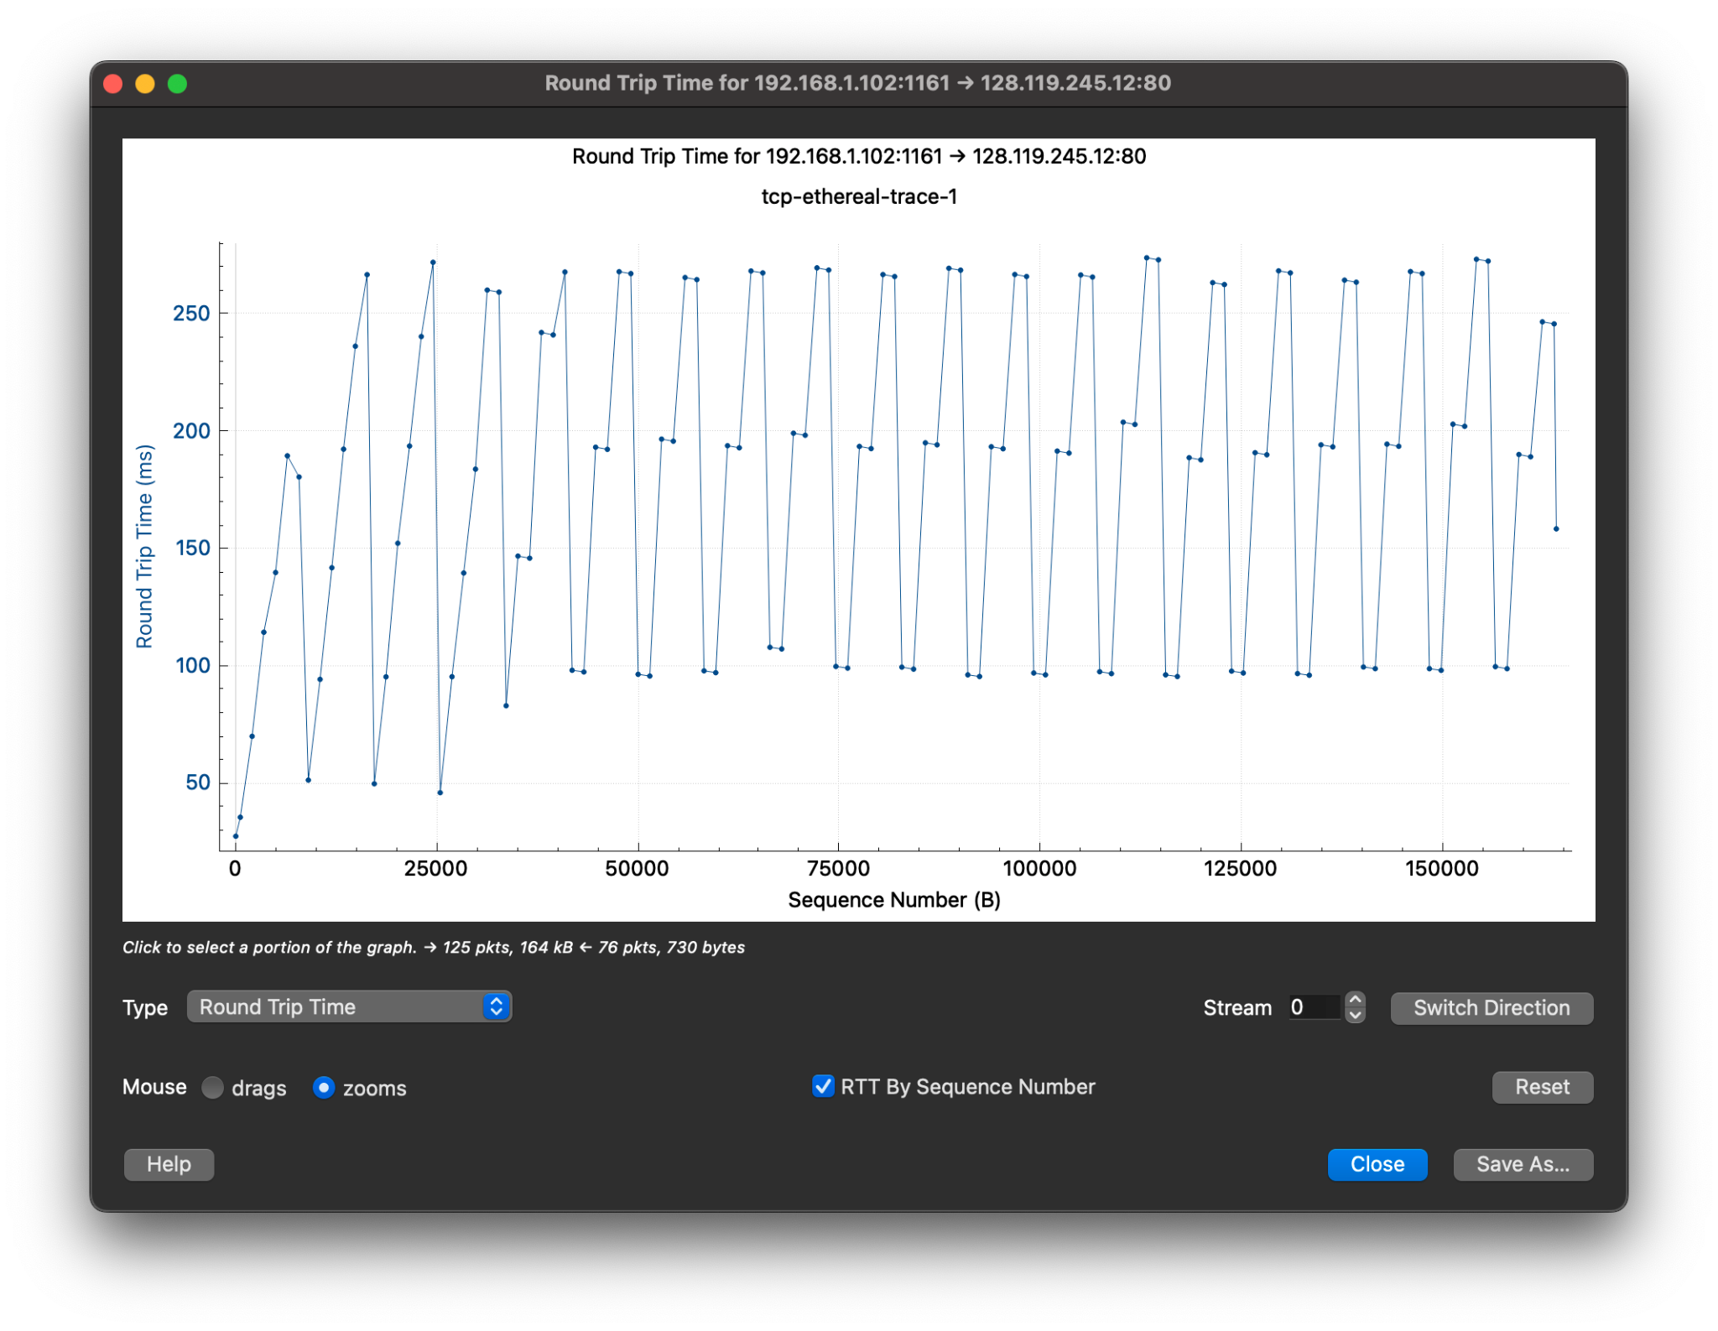

Round Trip Time Graph

1. *What is the length of each of the first six TCP segments?*

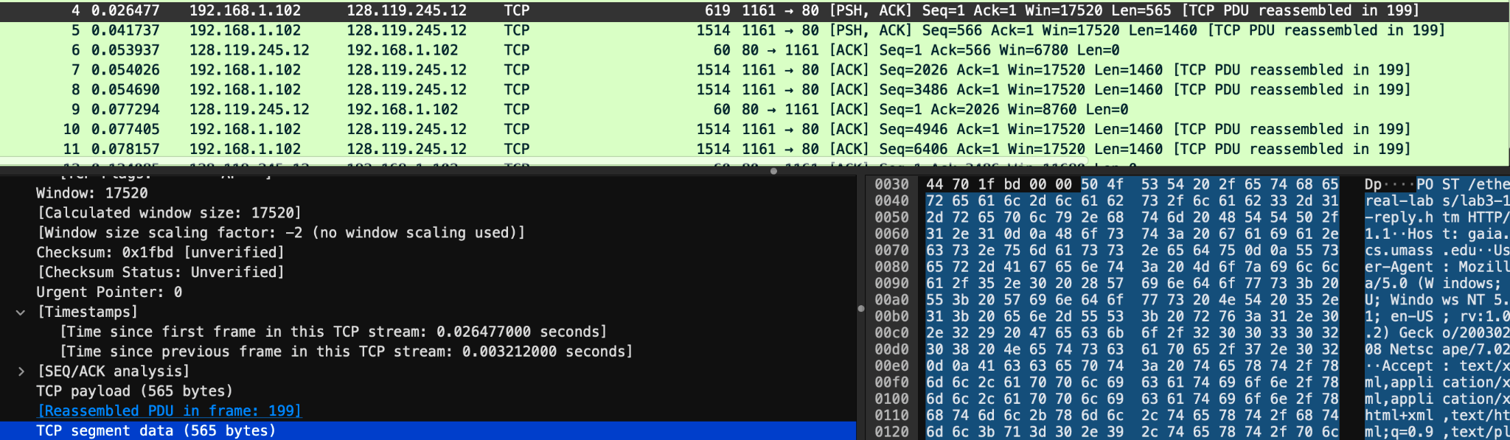

**Answer:**

**1st TCP segment:** 565 bytes

**2nd-6th TCP segments:** 1460 each

1. *What is the minimum amount of available buffer space advertised at the received for the entire trace?*

*Does the lack of receiver buffer space ever throttle the sender?*

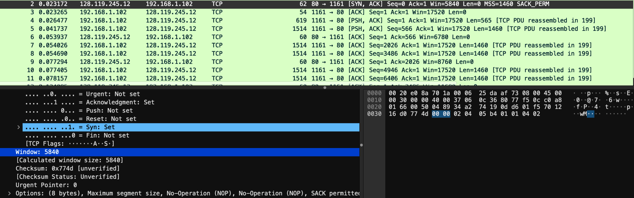

**Answer:**

1. the minimum amount of available buffer space advertised at the received for the entire trace is 5840
2. This receiver window grows steadily until a maximum receiver buffer size of 62780 bytes. The sender is never throttled due to lacking of receiver buffer space by inspecting this trace.
3. *Are there any retransmitted segments in the trace file?*

*What did you check for (in the trace) in order to answer this question?*

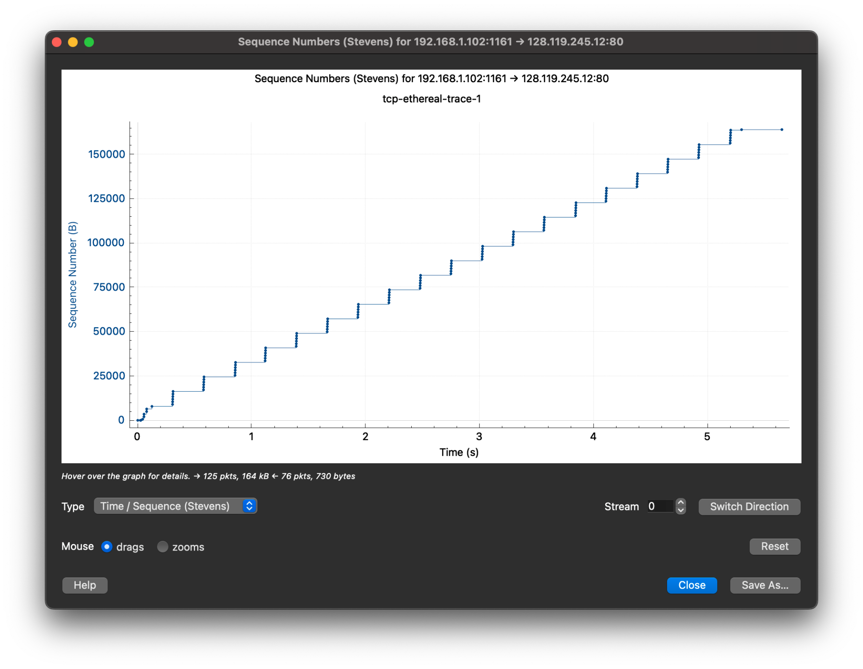

**Answer:** There are no retransmitted segments in the trace file. I checked this using the Time-Sequence Graph (Stevens) - the sequence numbers go up monotonically over time without going backward or repeating. If there were retransmissions, the graph would show a drop or repeat in the sequence numbers, but this is not the case here.

1. *How much data does the receiver typically acknowledge in an ACK?*

*Can you identify cases where the receiver is ACKing every other received segment?*

**

**Answer:**

1. The difference between the acknowledged sequence numbers of two consecutive ACKs indicates the data received by the server between these two ACKs.
2. After the client sends segments 7 and 8 (Seq=2026 and Seq=3486), the server sends a single ACK in segment 9 (Ack=2026) instead of separate ACKs for each.

Similarly, after segments 10 and 11, the server sends one ACK in segment 12 (Ack=3486), confirming both segments at once.

1. *What is the throughput (bytes transferred per unit time) for the TCP connection?*

*Explain how you calculated this value.*

**

**Answer:** the throughput for the TCP connection is **30,222 bytes/sec**

The TCP throughput is calculated as the total amount of data transferred divided by the total time of the connection.

First, we look at the first segment (No. 4), which starts with sequence number 1, and the last ACK (No. 202), which acknowledges sequence number 164091.

So, the total data transferred = 164091 - 1 = 164090 bytes.

Next, we check the time:

First segment time = 0.026477 seconds

Last ACK time = 5.455830 seconds

Total transmission time = 5.455830 - 0.026477 = 5.4294 seconds

Finally, we calculate the throughput:

Throughput = 164090 bytes / 5.4294 seconds ≈ 30,222 bytes/sec

## 4. TCP congestion control in action

1. *Use the Time-Sequence-Graph(Stevens) plotting tool to view the sequence number versus time plot of segments being sent from the client to the gaia.cs.umass.edu server.*

*Can you identify where TCP’s slow start phase begins and ends, and where congestion avoidance takes over?*

*Comment on ways in which the measured data differs from the idealized behaviour of TCP that we’ve studied in the text.*

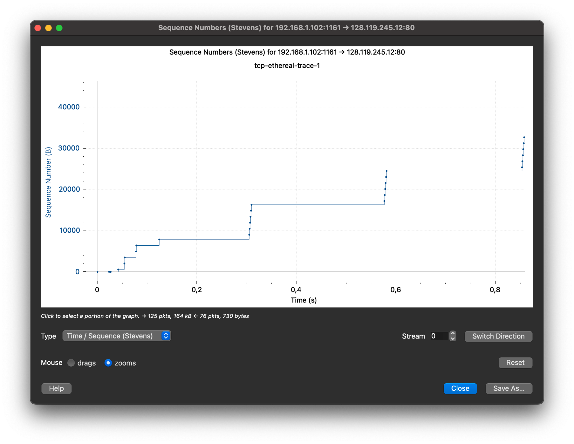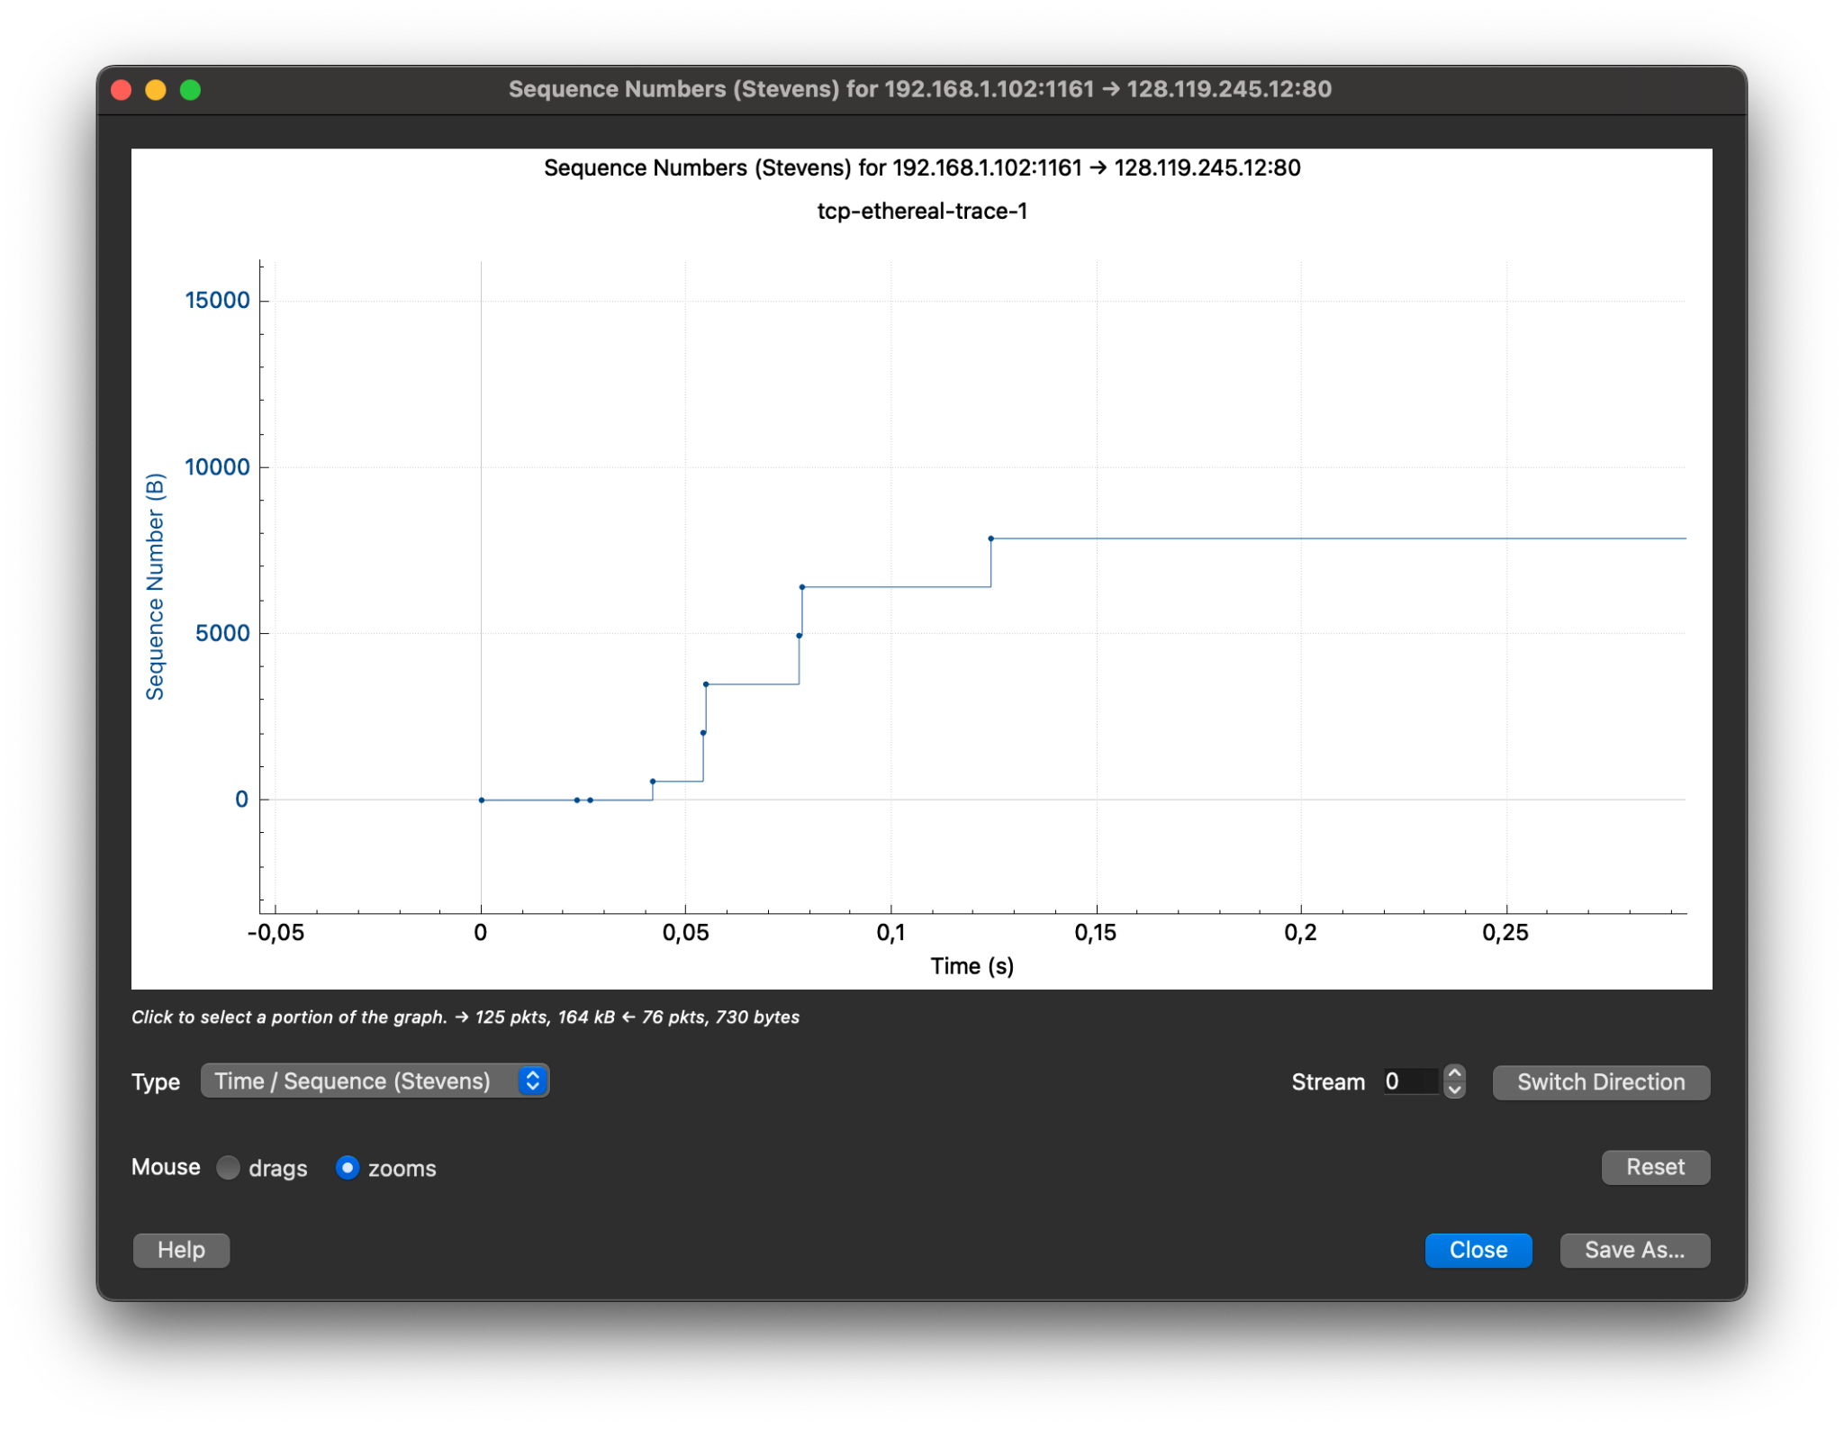

**Answer:** The ACK delays are around ~0.03 seconds after receiving the segments. In all cases, ACKs are sent promptly according to standard TCP behaviour. There are no noticeable delays in acknowledgments. Thus, ACKs are not delayed and are sent shortly after the segments are received.

1. *Answer each of two questions above for the trace that you have gathered when you transferred a file from your computer to* [*gaia.cs.umass.edu*](http://gaia.cs.umass.edu) 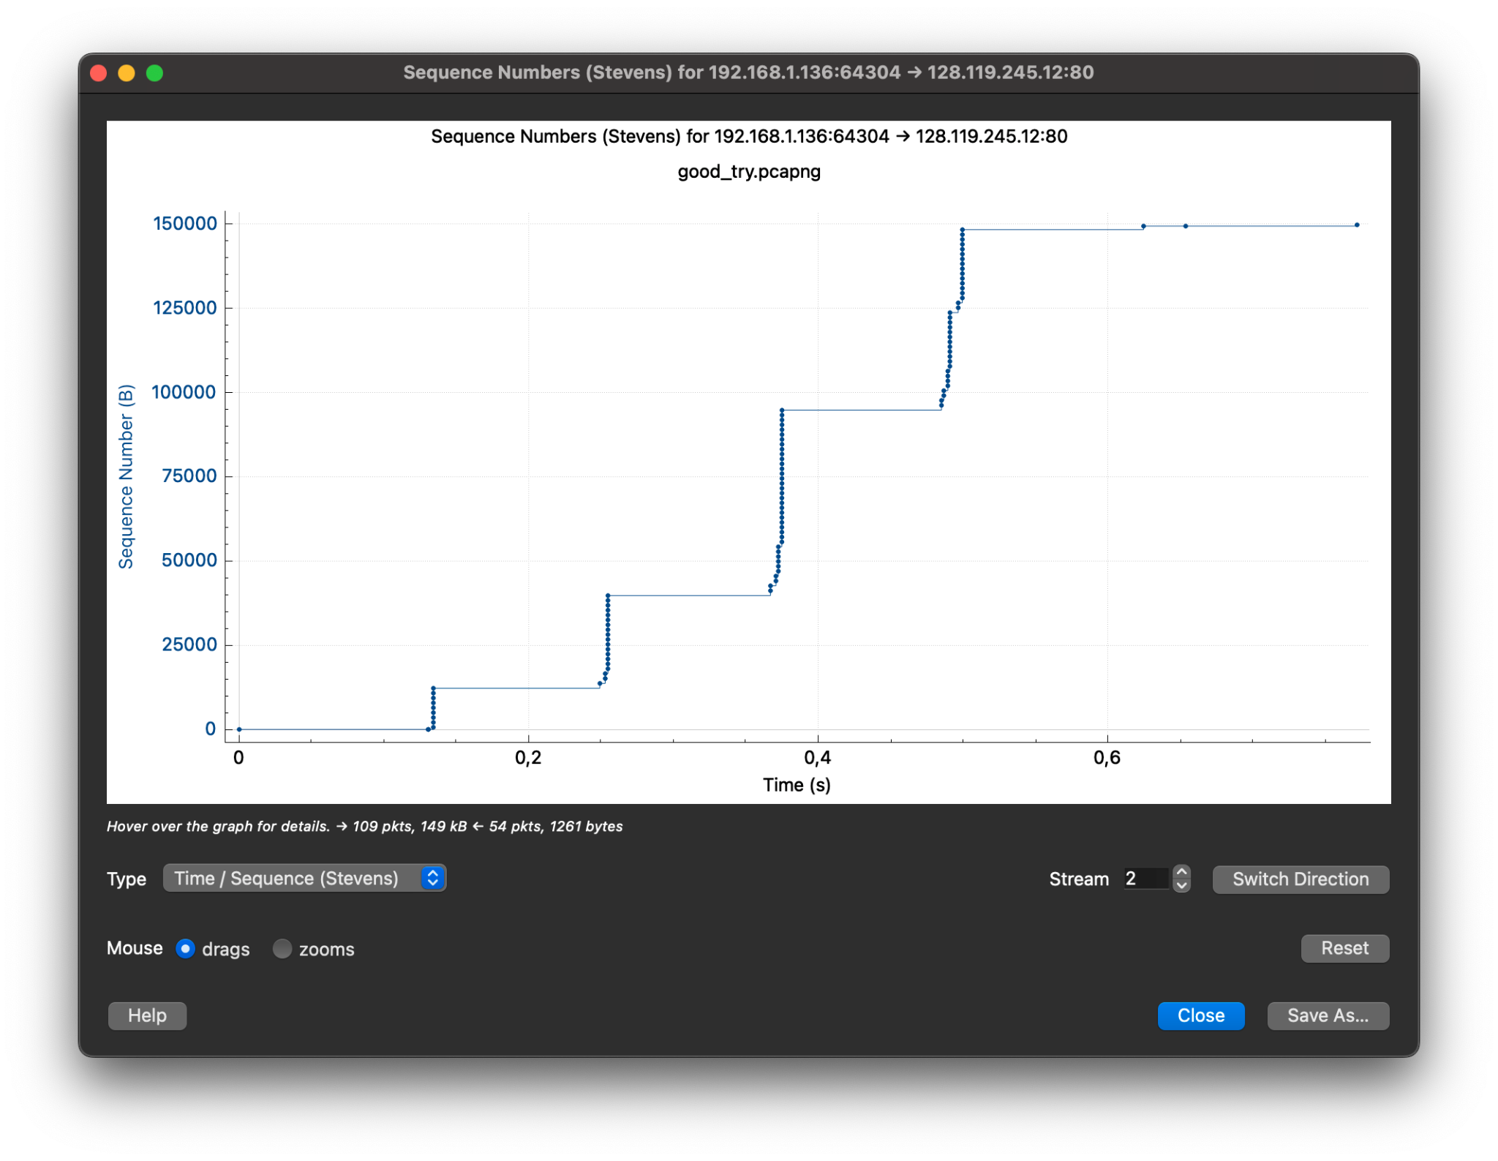

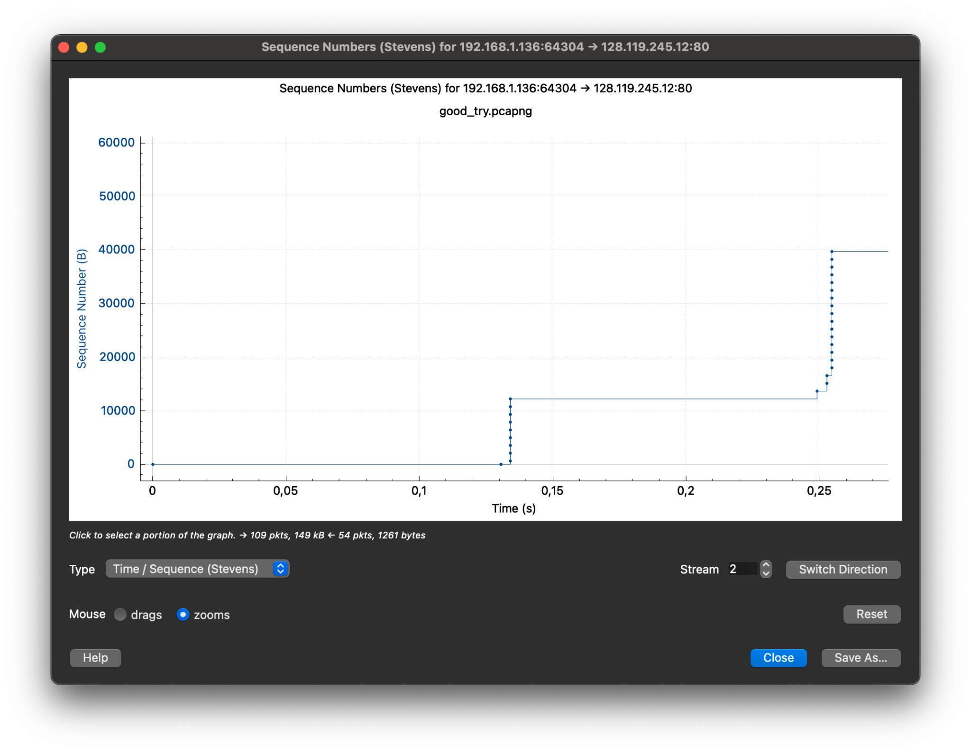 **Answer:** The graphs show that the file transfer occurs with some pauses between segments. In the beginning, there is a smooth increase in the number of transmitted bytes, indicating a good connection state. Later, a plateau appears - this is the point where a segment is lost (no increase in bytes), followed by retransmission. This is a typical case of TCP segment loss, which reduces transfer efficiency because the sender must wait for a timeout or three duplicate ACKs before retransmitting. Therefore, the graphs clearly indicate segment loss, which leads to retransmission and decreased efficiency.